Pre-requisite Verification:

1. Make sure you have the .NET 3.5 Framework installed on your server
2. Ensure you have the following drive structure created on your new SQL Server
   1. C Drive (OS)
   2. D Drive (System DB)
   3. E Drive (User DB)
   4. F Drive (Logs)
   5. G Drive (TempDB)
   6. O Drive (Optical DVD Drive)
   7. S Drive (PageFile)
3. Verify the page file for the server is relocated to the S Drive and not set by default to use the C Drive
4. Ensure the most current CU update is in the installation directory for both the enterprise and standard edition install directories for SQL Server 2014 with SP1:
   1. \\oak\information technology\Data Management\SQL Server 2014\WithSP1\SQL2014wSP1STD\Updates
   2. \\oak\information technology\Data Management\SQL Server 2014\WithSP1\SQL2014wSP1ENT\Updates
5. Select your installation type and requirements. The configurations below will create a new instance of SQL Server 2014 SP1 with the current CU installed and the appropriate services installed and configured to our best practice standards.
   1. SSRS Server with SQL Engine and Tools

(Install_Standard_SQLwithSSRS.cmd) – For SQL Server 2014 Standard Edition

(Install_Enterprise_SQLwithSSRS.cmd) – For SQL Server 2014 Enterprise Edition

\\oak\information technology\Data Management\scripts\mssql\SilentInstallation\2014SP1\

* 1. SQL Server with SQL Engine and Tools

(Install_Standard_SQLwithTools.cmd) – For SQL Server 2014 Standard Edition

(Install_Enterprise_SQLwithTools.cmd) – For SQL Server 2014 Enterprise Edition

\\oak\information technology\Data Management\scripts\mssql\SilentInstallation\2014SP1\

* 1. SQL Server with SQL Engine, SSIS and Tools

(Install_Standard_SQLwithSSSISwithTools.cmd) – For SQL Server 2014 Standard Edition

(Install_Enterprise_SQLwithSSISwithTools.cmd) – For SQL Server 2014 Enterprise Edition

\\oak\information technology\Data Management\scripts\mssql\SilentInstallation\2014SP1\

* 1. SQL Server with SSIS and Tools

(Install_Standard_SSISwithTools.cmd) – For SQL Server 2014 Standard Edition

(Install_Enterprise_SSISwithTools.cmd) – For SQL Server 2014 Enterprise Edition

\\oak\information technology\Data Management\scripts\mssql\SilentInstallation\2014SP1\

1. If you create a new Configuration.ini file for deploying a SQL Server 2014 instance ensure you have updated the following items:
   1. Remove the UIMODE=”Normal” together with the comment above it
   2. Change the QUIET parameter to “True” instead of “False”
   3. Remove the ADDCURRENTUSERASSQLADMIN="False" together with the comment above it as we are not installing Express editions most of the times (if you are – keep that in the configuration file)
   4. Add IACCEPTSQLSERVERLICENSETERMS="True" somewhere in the file (for example at the top of it)
   5. Change the Update Location and Flags to use the local path for already downloaded patches.
      * ; Specify the location where SQL Server Setup will obtain product updates. The valid values are "MU" to search Microsoft Update, a valid folder path, a relative path such as .\MyUpdates or a UNC share. By default SQL Server Setup will search Microsoft Update or a Windows Update service through the Window Server Update Services.

UpdateSource=".\Updates"

* 1. ; If this parameter is provided, then this computer will use Microsoft Update to check for updates.

USEMICROSOFTUPDATE="False"

* 1. ; Specify whether SQL Server Setup should discover and include product updates. The valid values are True and False or 1 and 0. By default SQL Server Setup will include updates that are found.

UpdateEnabled="True"

Configure Imperva and TSMSQL SQL permissions and disable the SA account after the server is installed by running the following post deployment script:

USE [master]

GO

--Create Imperva User with sysadmin privileges

CREATE LOGIN [FHLBDM\impsrv_user] FROM WINDOWS WITH DEFAULT_DATABASE=[master], DEFAULT_LANGUAGE=[us_english]

GO

ALTER SERVER ROLE [sysadmin] ADD MEMBER [FHLBDM\impsrv_user]

GO

--Create TSMSQL User with sysadmin privileges

CREATE LOGIN [FHLBDM\tsmsql] FROM WINDOWS WITH DEFAULT_DATABASE=[master], DEFAULT_LANGUAGE=[us_english]

GO

ALTER SERVER ROLE [sysadmin] ADD MEMBER [FHLBDM\tsmsql]

GO

--Disable SQL SA Login Account

Alter Login sa disable;

Update SQL Server Backup Path to be the following:

\\fhlbdm.com\sqlbackup\sqlbackup\%servername%

Run the following script after you update the servername appropriately:

EXEC master..xp_regwrite

@rootkey='HKEY_LOCAL_MACHINE',

@key='SOFTWARE\Microsoft\Microsoft SQL Server\MSSQL12.MSSQLSERVER\MSSQLServer',

@value_name='BackupDirectory',

@type='REG_SZ',

@value='\\fhlbdm.com\sqlbackup\sqlbackup\servername'

After running this script navigate to the following entry in your backupdirectory key with the appropriate server name

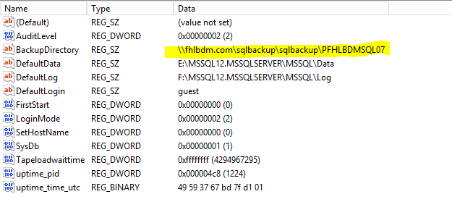

Ensure you have patched the SQL Native Client Driver to the most current version located here:

\\oak\information technology\Data Management\SQL Server 2014\CumulativeUpdate

Add Server to PFHLBDMSQL08 Central Management Registration

Install Imperva

Install Foglight